Co-ordinates of the fourth point of a parallelogram,when its 3 co-ordinates are known, is-

Dx=(Ax+Cx)-Bx …….(1)

Dy=(Ay+Cy)-By…….(2)

Area of a parallelogram when its 4 co-ordinates are known, is-

| 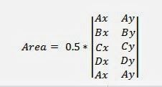

Or, Area =0.5\*( (Ax\*By)-(Ay\*Bx)+(Bx\*Cy)-(By\*Cx)+(Cx\*Dy)-(Cy\*Dx)+(Dx\*Ay)-(Dy\*Ax))……..(3)